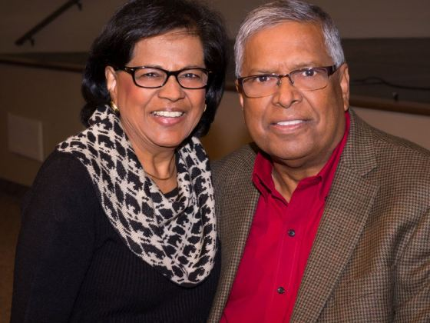  Date  Church Pastor  Church Address: | Rev. M. Mark Seenarine  ────  Pastor  Evangelist  ────  Preaching  Teaching  Word of Knowledge  Healing  ────  Don’t Miss One Minute of this  Exciting Service  ────  Everyone Is Welcome!  Harvest Time Ministries Inc.  213 Michelle Lane  Madison, Ohio 44051  www.harvesttimeinc.org  Web Address  Dates and Times

